**Paul Blessing**

**Exploring Weather Trends**

**January 22, 2018**

***Finding the Correct Data***

1. First, I had to find my data and ensure it was accurate.

I used the following SQL statement to find the data I needed for global temperatures:

**SELECT \***

**FROM global_data;**

1. Next, I had to find the closest city to me within the database. I tried searching for Cleveland but it wasn’t there. So, I tried Columbus and was successful with the following SQL statement:

**SELECT city, country**

**FROM city_list**

**WHERE city LIKE ‘Col%’ AND country LIKE ‘United%’;**

1. Finally, I found the temperature data for Columbus with the following SQL statement:

**SELECT \***

**FROM city_data**

**WHERE city LIKE 'Columbus' AND country Like 'United States';**

***Making Sense of the Data***

I then placed the data within excel and found the 14-year moving average for the global and city(Columbus) temperatures. I did this with the following formula: =AVERAGE(D2:D15) and then simply ran the formula down the column so it would adjust to (D3:D16), (D4:D17) and so on. I chose 14 years as the data set was quite large.

***Making the Visualization***

I decided to use gradient coloring to highlight the peaks and valleys of the data trends. I also made sure to have labels for each axis to ensure the viewer would understand the visualization. Additionally, I created a legend to make it obvious which line corresponded with each data set. I placed the year on the horizontal axis and the temperature in degrees Celsius on the vertical axis.

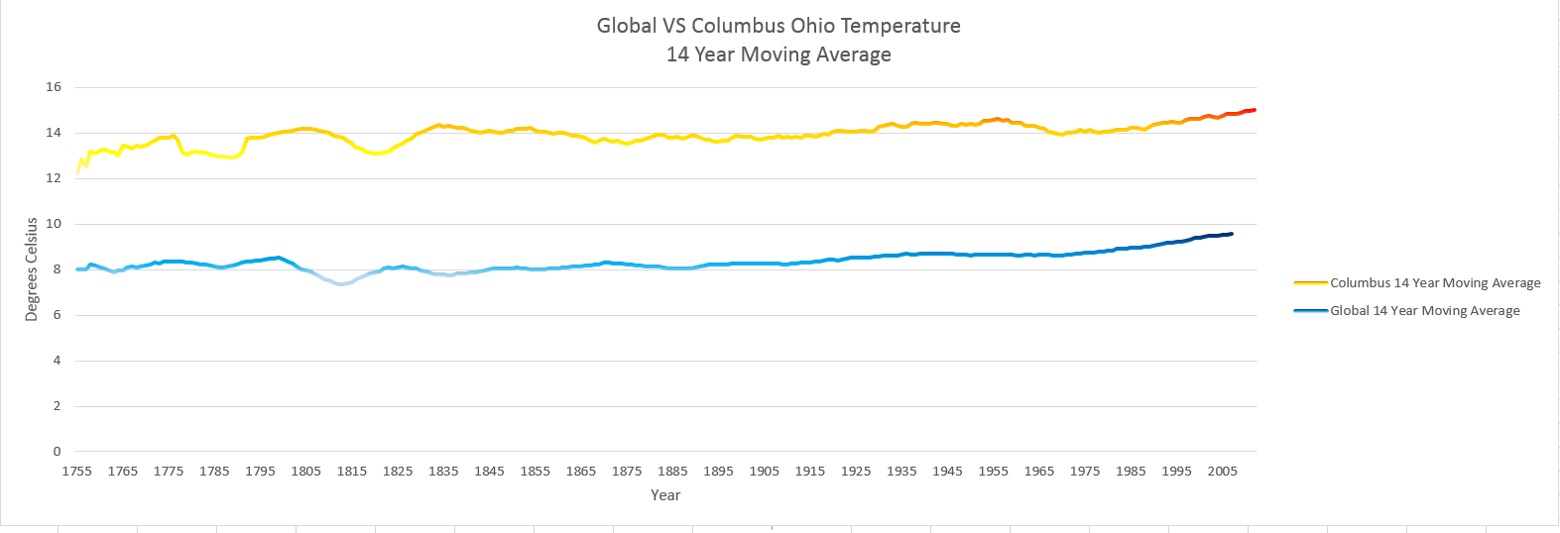

***Observations***

1. It appears that Columbus has higher average temperatures than the global temperatures. I feel that this comparison is specious however, and will explain in another observation.
2. Both my city and the global temperatures seem to be rising slowly but surely over time. However, Columbus had a strange cooling period between 1965 and 1985. Alternatively, the global temperatures have steadily risen. Also, both Columbus and global temperatures seem to have been quite volatile from 1755-1825. This may have been because of poor standards of measurement, as both data sets had missing data during these times.
3. I find the comparison between Columbus and global temperatures specious because global temperature ostensibly contains temperatures from incredibly disparate environments such as: Antarctica, the Sahara, Death Valley, and the Mediterranean. These environments changes may be different from each other and the overall trend could be distorted by areas that have had large fluctuations. A deeper analysis would be necessary.
4. The temperatures for both data sets seems to start rising in the late 1800’s this may correlate with the industrial revolution and the increase of artificial heat being made by human inventions.